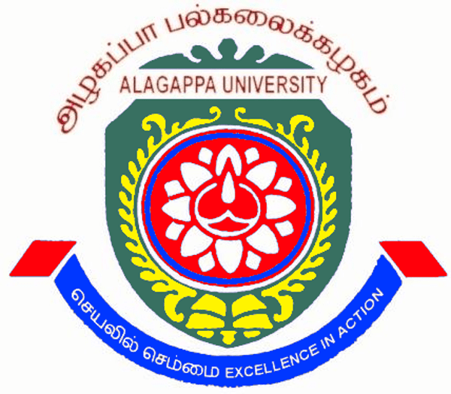
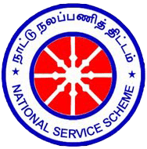
ALAGAPPA UNIVERSITY
(Accredited with A+ Grade by NAAC (CGPA : 3.64) in the Third Cycle)
KARAIKUDI – 630 003

NATIONAL SERVICE SCHEME

Coordinator

Dr. P. SRINIVASAN
Department of Animal Health and Management

University Departments - Programme Officers

S. No. | Name of the Programme Officer | Unit No.
1. | Dr. K. Mahesh  Department of Computer Applications | 2
2. | Dr. J. Vimala  Department of Mathematics | 3
3. | Dr. K. Chitra Devi  Department of International Business | 4
4. | Dr. S. Thambidurai  Department of Industrial Chemistry | 49
5. | Mr. K. P. Karthilingam  Institute of Catering Science and Hotel Management | 89
6. | Dr. K. Divya  Alagappa University College of Physical Education | 91
7. | Dr. K. Sundar  Alagappa University College of Physical Education | 82
8. | Dr. M. Sivakumar  Department of Physics | 1
9. | Dr. G. Sivakumar  Alagappa University College of Education | 90

National Service Scheme (NSS) Advisory Committee - University Level
(2017-18)

1 | Prof. S. Subbiah  Vice-Chancellor  Alagappa University  Karaikudi – 630003 | Chairman
2 | Prof. H. Gurumallesh Prabu  Registrar  Alagappa University  Karaikudi – 630003 | Member
3 | The Finance Officer  Alagappa University  Karaikudi – 630003 | Member
4 | The Regional Director  Regional Directorate of NSS  4 th Block IV Floor, ‘B’ Wing, Shastri Bhavan, Chennai- 600 006 | Member
5 | The State NSS Officer  Tamilnadu State NSS Cell  Directorate of Collegiate Education  10th Floor, E.V.K Sampath Maligai, College Road, Nungambakkam,  Chennai – 600006 | Member
6 | Dr. S. Kaliyamoorthy  Professor & Director,  Alagappa Institute of Management  Alagappa University, Karaikudi – 630003 | Member
7 | Dr. A. Narayanamoorthy  Syndicate Member  Professor & Head  Department of Economics & Rural Development  Alagappa University, Karaikudi – 630003 | Member
8 | Dr. K. Gurunathan  Syndicate member  Professor & Head,  Department of Nanoscience and Technology  Alagappa University, Karaikudi – 630003 | Member
9 | Dr. S. Karutha Pandian  IQAC Co-ordinator  Alagappa University, Karaikudi - 630003 | Member
10 | Dr. M. Pandi  Professor & Head, Department of Tamil  Alagappa University  Karaikudi – 630003 | Member
11 | The Commissioner  Karaikudi Municipality, Karaikudi | Member
12 | The Coordinator,  NSS Empanelled Training Institution,  Avinashilingam University, Coimbatore – 641043 | Member
13 | The Principal  Vidhyaa Giri College of Arts & Science  Puduvayal, Karaikkudi – 630108 | Member
14 | The Principal  Syed Hameetha Arts &Science College  Kilakarai - 623806 | Member
15 | The Programme Officer  National Service Scheme,  Raja Duraisingam Govt. Arts College, Sivagangai – 630561 | Member
16 | The Programme Officer  National Service Scheme  Madurai Sivakasi Nadar’s Pioneer Meenakshi College for Women, Poovanthi. | Member
17 | The Secretary  Rotary Club  Karaikudi | Member
18 | Dr. M.Gurupandi  Assistant Professor,  Department of International Business and Commerce & Zonal Coordinator –YRC, Alagappa University  Karaikudi - 630003 | Member
19 | Dr. K. Mahesh  Professor, Department of Computer Application &  Cultural Coordinator  Alagappa University, Karaikudi - 630003 | Member
20 | Dr. S. Rajaram  Director i/c,  Directorate of Distance Education  Alagappa University  Karaikudi - 630003 | Member
21 | Dr. B. Dharmalingam  Director, Skill Development Centre  Alagappa University  Karaikudi - 630003 | Member
22 | Student Representatives  G. Ajith  M. Sc., II Year, Department of Animal Health & Management  &  R. Gayathri  M. Sc., II Year, Department of Physics  Alagappa University, Karaikudi - 630003 | Members
23 | Dr. P. Sinivasan  Programme Co-ordinator  National Service Scheme  Alagappa University, Karaikudi - 630003 | Member Secretary

Contact

Programme Coordinator
National Service Scheme & Red Ribbon Club
Alagappa University
Alagappapuram
Karaikudi – 630 003
Sivagangai District, Tamil Nadu
INDIA
E-mail: nsscoau@gmail.com
Contact No: +91 4565-223209
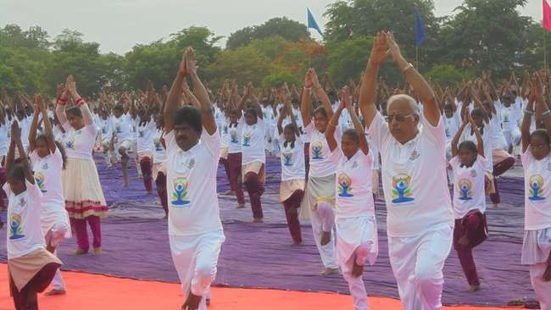
INTERNATIONAL YOGA DAY on 21.06..2016
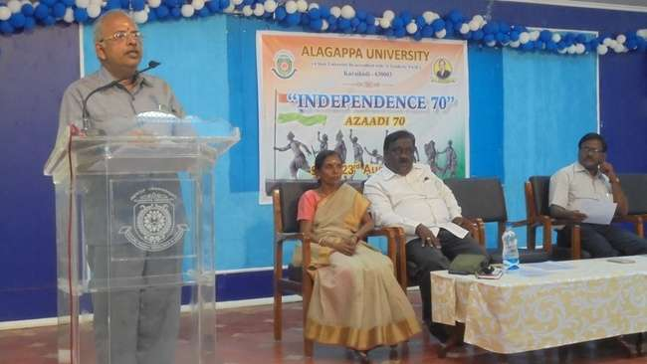
INDEPENDENCE 70 Quit India Day Programme on 09.08.2016

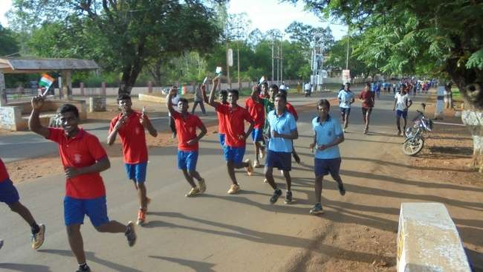

INDEPENDENCE 70 – Independence Day Run on 14.08.2016

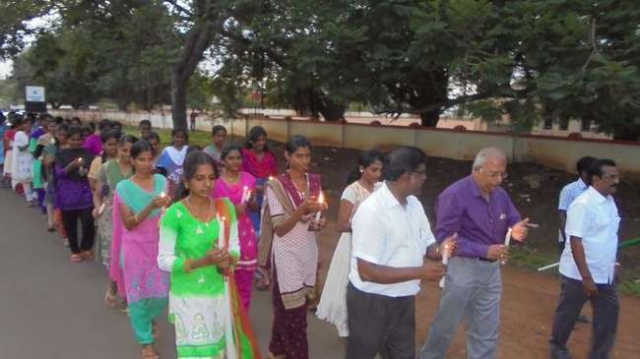
INDEPENDENCE 70 – CANDLE LIGHT FREEDOM MARCH PROGRAMME on 14.08.2016

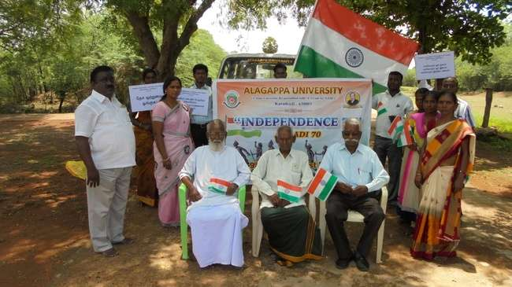
INDEPENDENCE 70 - Students’ visit to the birth place of freedom fighters on 22.08.2016
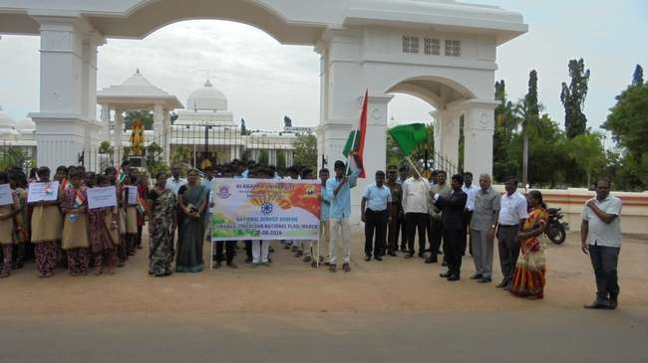
TIRANGA MARCH on 22.08.2016

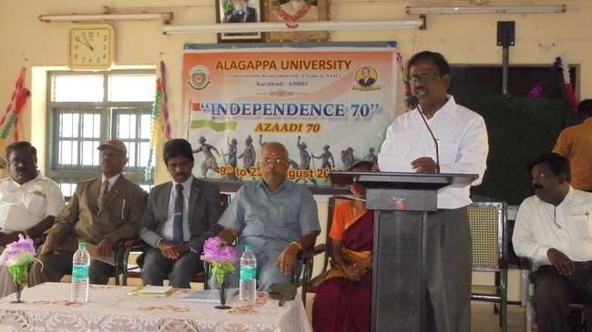
INDEPENDENCE 70 – Mass singing of the National Anthem on 23.08.2016

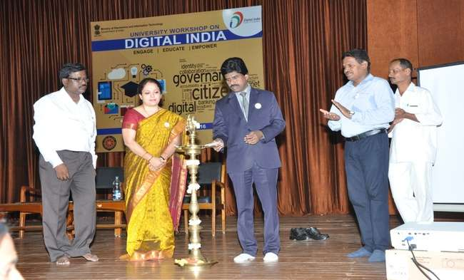
DIGITAL INDIA PROGRAMME on 30.09.2016
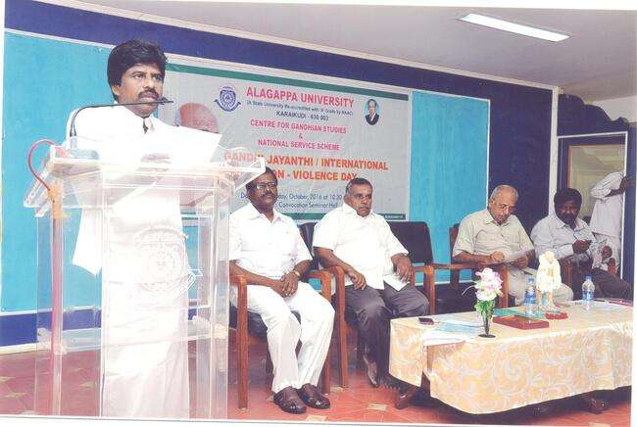

GANDHI JEYANTHI on 02.10.2016
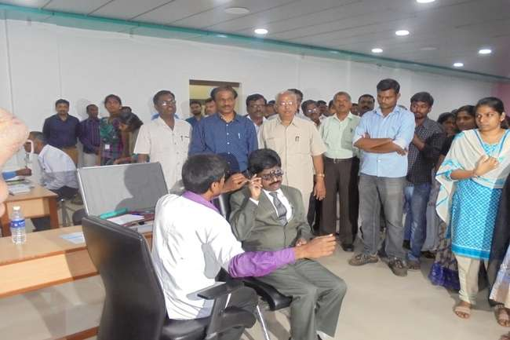

EYE CHECK-UP CAMP on 05.10.2016
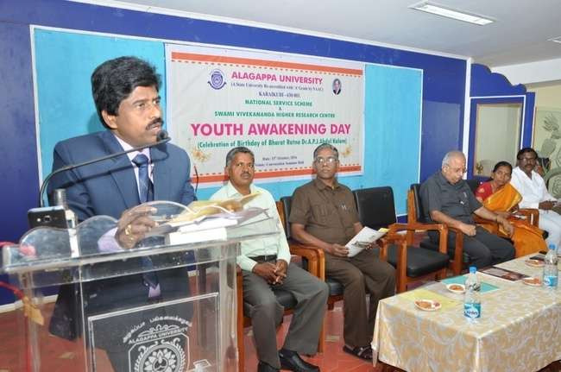
YOUTH AWAKENING DAY (Dr.A.P.J.ABDUL KALAM BIRTHDAY CELEBRATION) on 15.10.2016
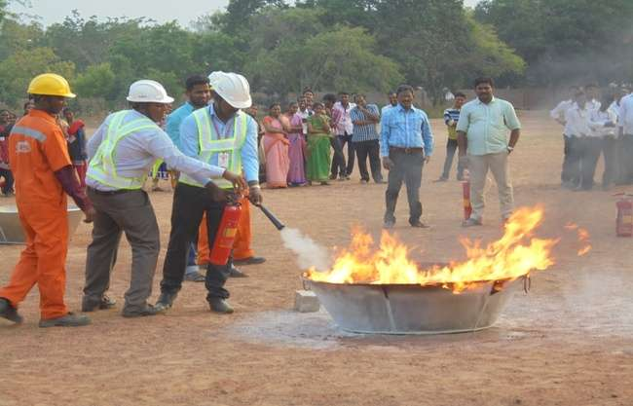
FIRE & SAFETY AWARNESS PROGRAMME on 19.10.2016
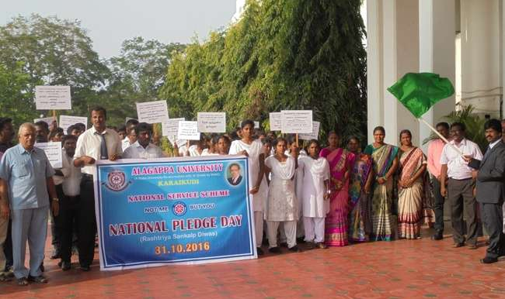
“RASHTRIYA SANKALP DIWAS” PROGRAMME on 31.10.2016
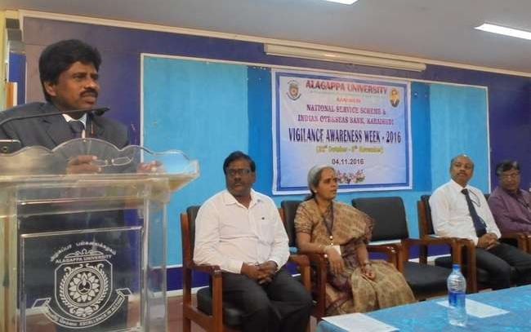
VIGILANCE AWARENESS PROGRAMME on 04.11.16
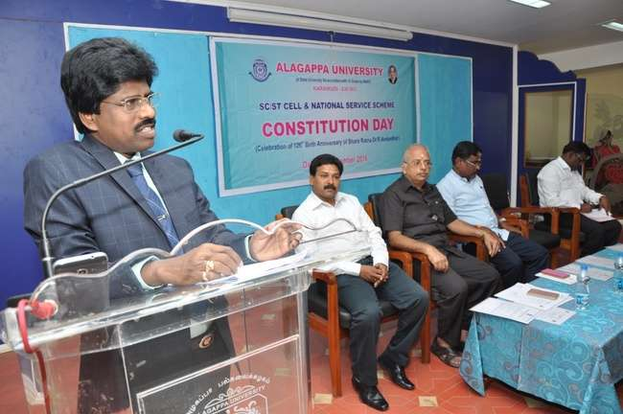
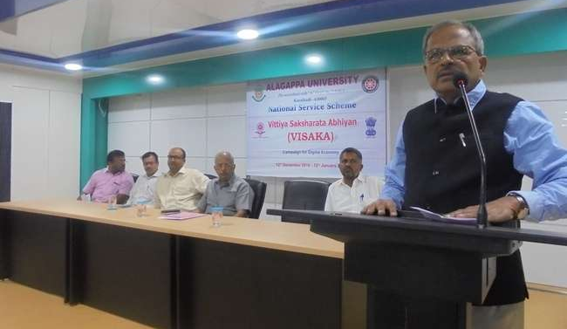
CONSTITUTION DAY on 26.11.16
VISAKA (Vittiya Shaksharata Abhiyan) PROGRAMME (12.12.2016-12.01.2017) on 19.12.2016

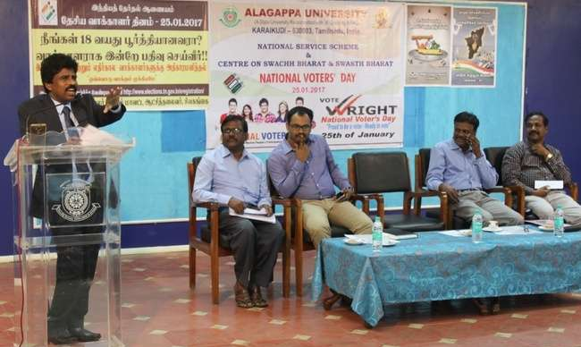
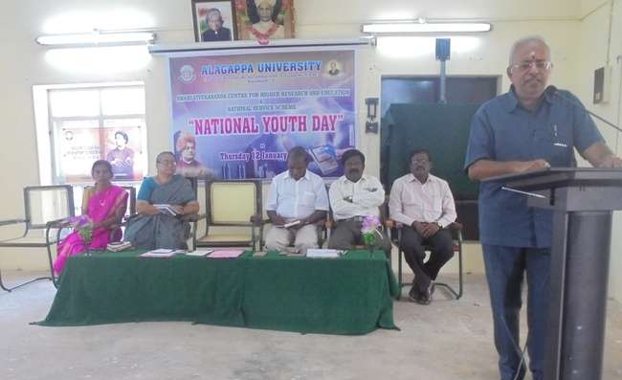
NATIONAL YOUTH DAY on 12.01.17
NATIONAL VOTER’S DAY on 25.01.17

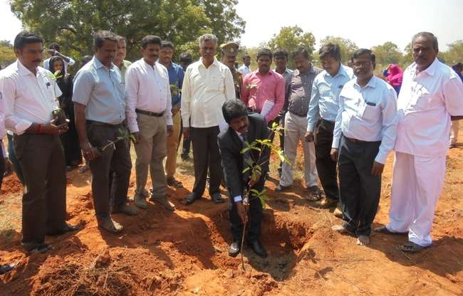
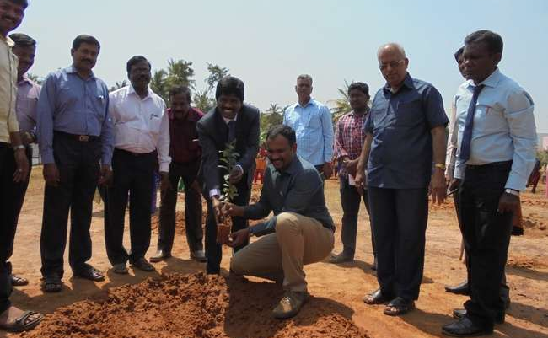
TREE PLANTATION PROGRAMME on 10.02.17
TREE PLANTATION PROGRAMME on 20.02.17
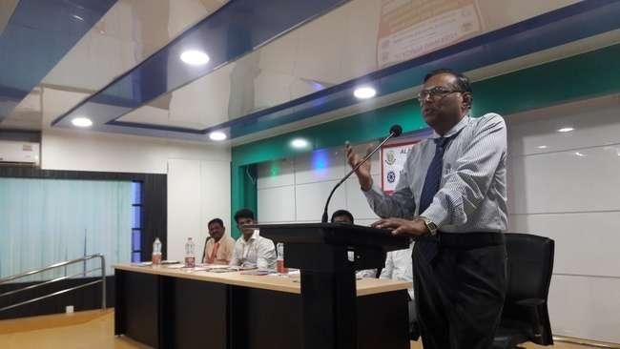
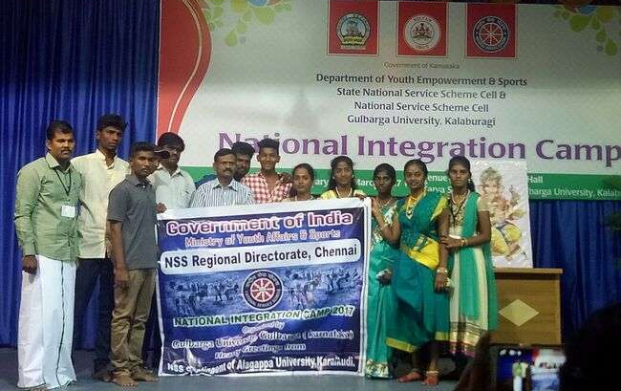
BLOOD STEM CELL DOANTION AWARENESS PROGRAMME AND BLOOD STEM CELL DONOR REGISTRY on 01.03.2017
OUR UNIVESITY TEAM PARTICIPATED IN THE
NATIONAL INTEGRATION CAMP
on 27.02.2017 – 05.03.2017 at GULBARGA UNIVERSITY, KARNATAKA

